9th Bordeaux Neurocampus
international conference

NeuroCompare
Comparative Neuronal Circuits
For Adaptive Behaviour

Bordeaux / 26 - 28 September 2023
Centre Broca Nouvelle-Aquitaine

http://brainconf.u-bordeaux.fr

Sponsoring application form

Scientific committee
- Arthur LEBLOIS, Institut des Maladies Neurodégénératives (IMN)
- Anna BEYELER, Neurocentre Magendie
- Etienne COUTUREAU, Institut de Neurosciences Cognitives et Intégratives d’Aquitaine (INCIA)
- Frédéric GAMBINO, Institut Interdisciplinaire des Neurosciences (IINS)
- Michel THIEBAUT DE SCHOTTEN, Institut des Maladies Neurodégénératives (IMN)

Abstract
Current research highlights the role of cortical networks in supporting higher order cognitive functions (e. g. decision making, working memory) and its functioning is systematically impaired in various psychiatric conditions (schizophrenia, depression, drug addiction). This global research effort has demonstrated a very high degree of functional parcellation within and between cortical networks. Networks with high homology have been identified from primate (including human) to rodent brains. The "Comparative Neuronal Circuits for adaptive behaviour" conference will gather worldwide experts together in Bordeaux Neurocampus to develop research and applications beyond the state of the art from cortical circuits research in rodents, to bat, to monkeys and humans. We will discuss two complementary dimensions: (1) the anatomy and connectivity of cortical circuits, and (2) the function of those circuits in adaptive behaviour.

Confirmed Speakers (alphabetical order):
Céline Amiez (Lyon University/CNRS, France)
Yaniv Assaf (Tel Aviv University, Israel)
Helen Barbas (Boston University, USA)
Anna Beyeler (Bordeaux University/INSERM, France)
Emiliano Bruner (Burgos University, Spain)
Long Ding (University of Pennsylvania, USA)
Julie Duque (ULB, Belgium)
Stefan Everling (Western University, Canada)
Leslie Fellows (McGill University, Canada)
Gabrielle Girardeau (Paris University/INSERM, France)
Karine Guillem (Bordeaux University/CNRS, France)
Suzanne Haber (Rochester University, USA)
Michael Halassa (MIT, USA)
Genevra Hart (UNSW, Australia)
Alicia Izquierdo (UCLA, USA)
Nicolas Mallet (Bordeaux University/CNRS, France)
Rony Paz (Weizmann Institute, Israel)
Seongmin Park (Lyon University/CNRS, France)
Mathias Pessiglione (Paris University/INSERM, France)
Daniela Popa (Paris University/CNRS, France)
Naoya Takahashi (Bordeaux University/CNRS, France)
Michel Thiebaut de Schotten (Bordeaux University/CNRS, France)
Nachum Ulanovsky (Weizmann Institute, Israel)
Mikael Zugaro (Paris University/CNRS, France)

Venue
Centre Broca nouvelle-Aquitaine
146, rue Léo Saignat
33000 Bordeaux - France
Access : https://www.bordeaux-neurocampus.fr/qui-sommes-nous/contacter-neurocampus/
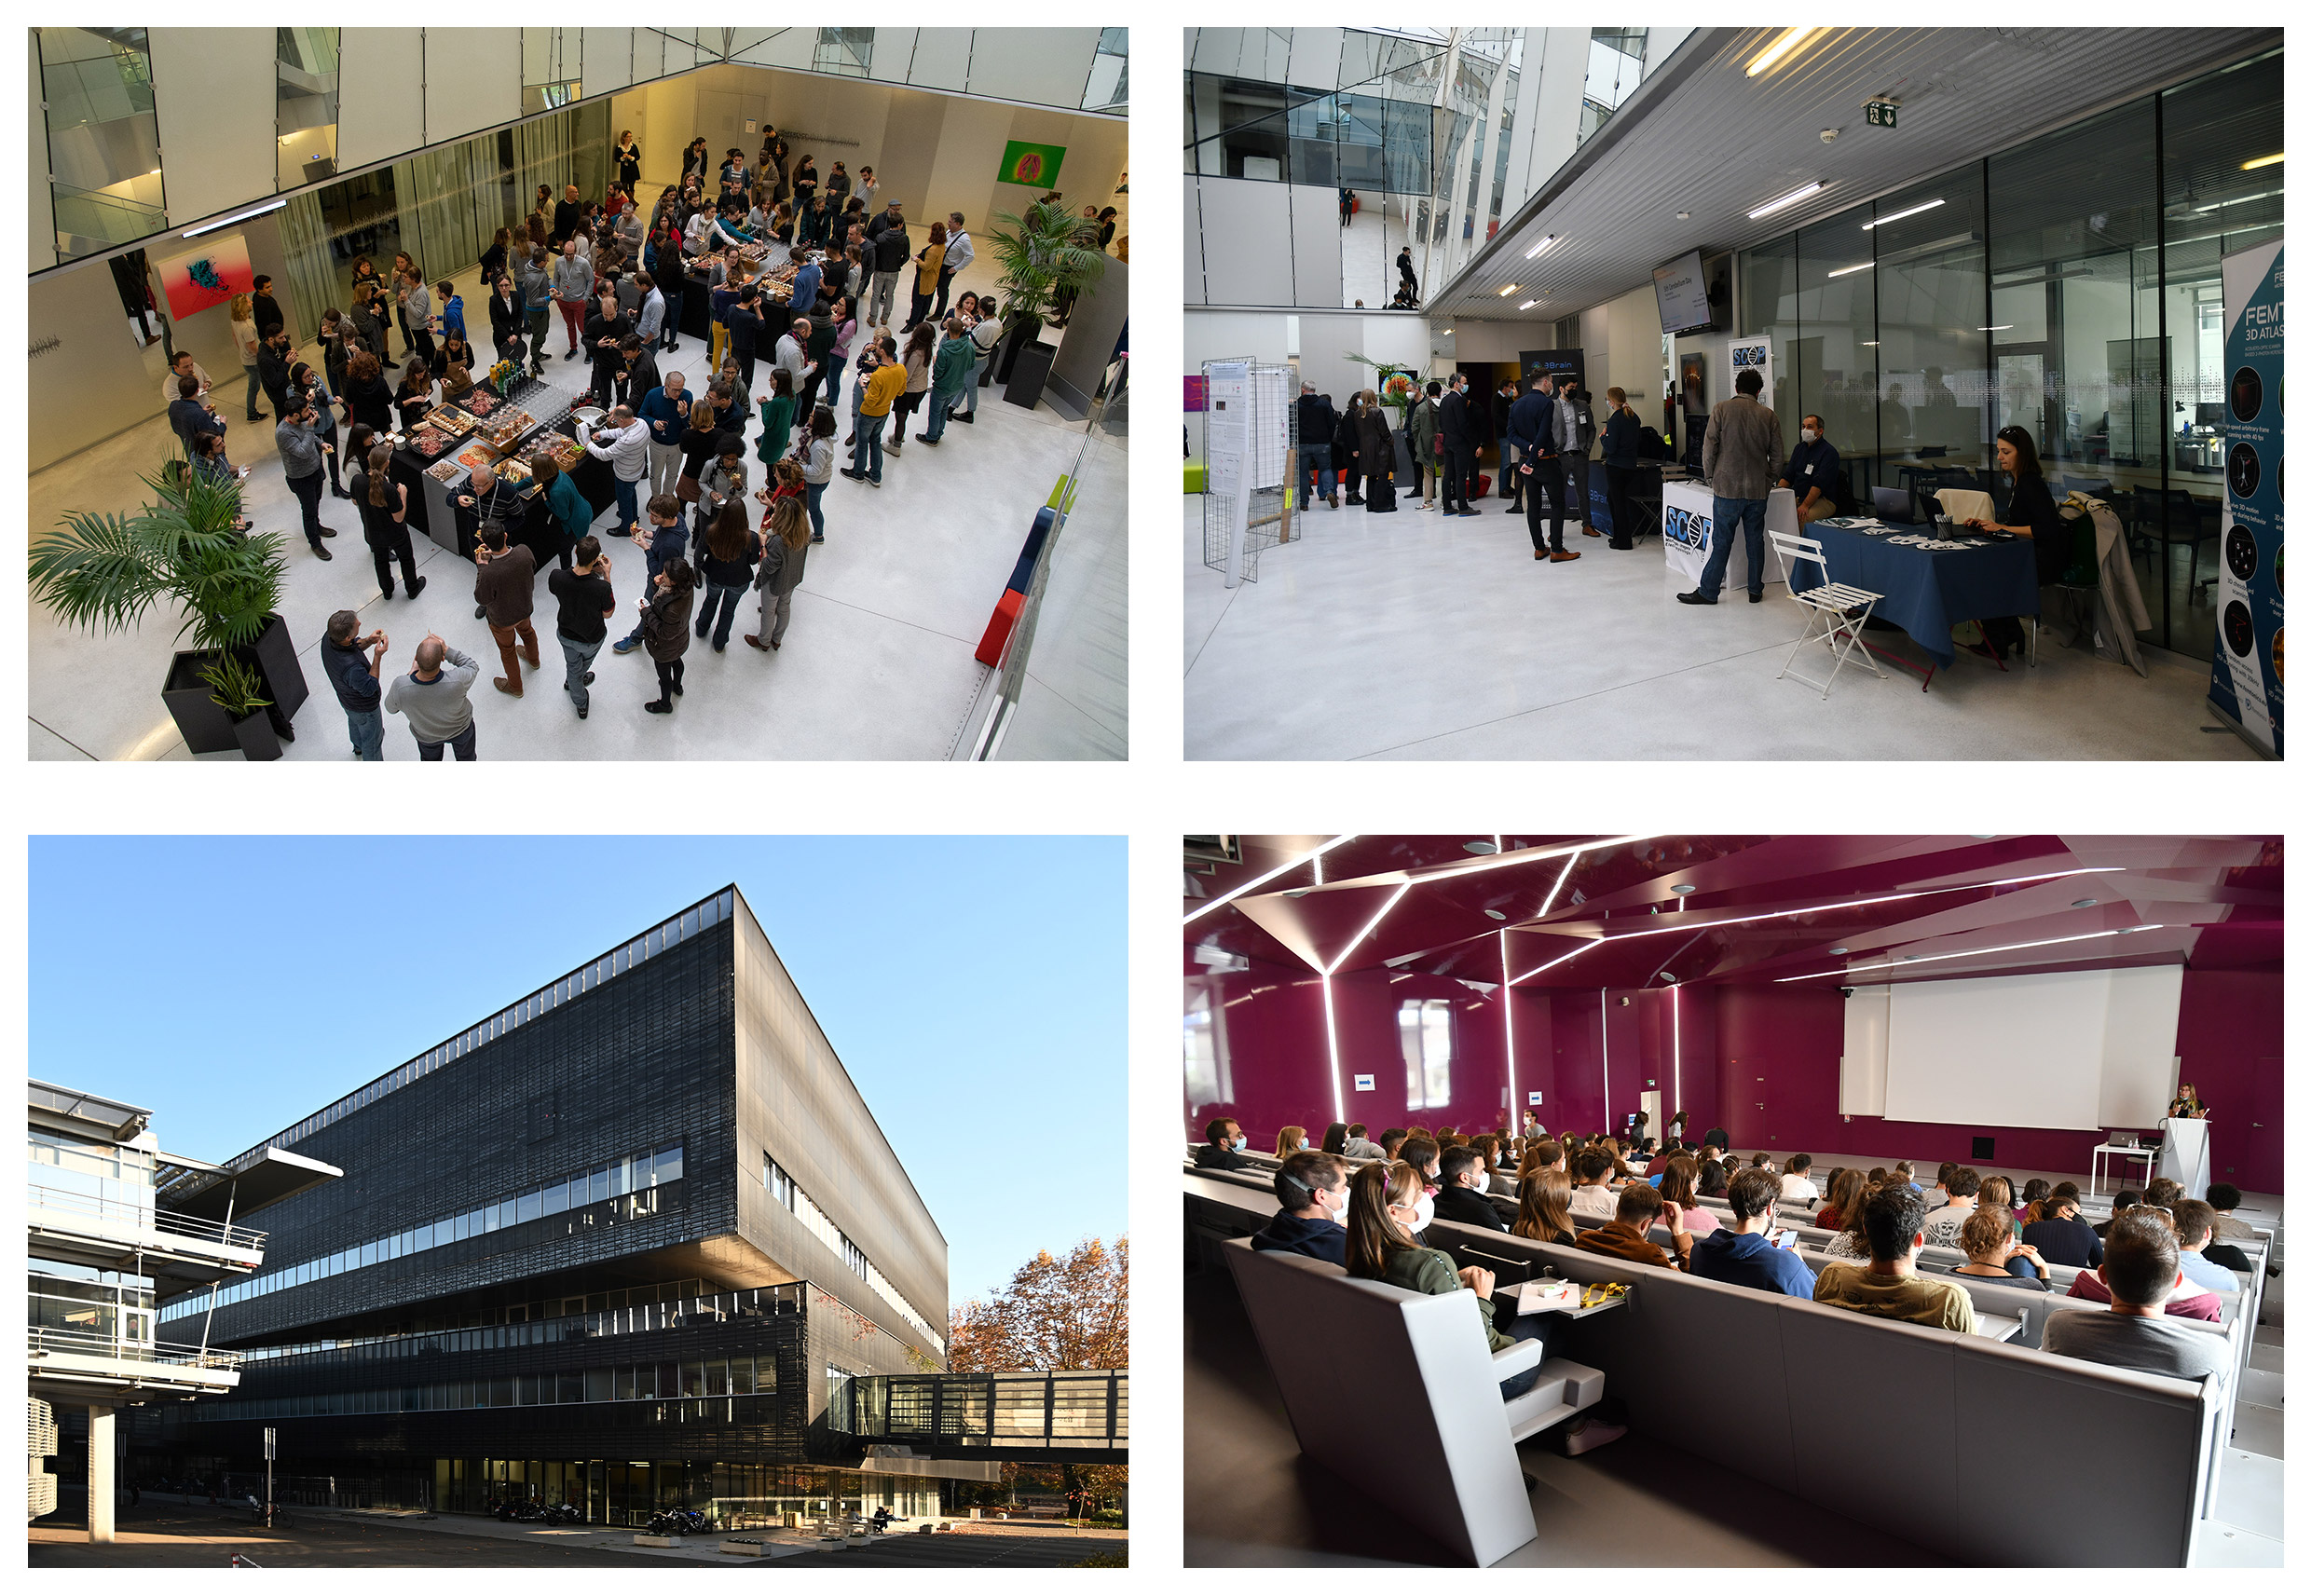

Contacts

Scientific committee
Arthur LEBLOIS : arthur.leblois@u-bordeaux.fr
Anna BEYELER : anna.beyeler@inserm.fr
Etienne COUTUREAU : etienne.coutureau@u-bordeaux.fr
Frédéric GAMBINO : frederic.gambino@u-bordeaux.fr
Michel THIEBAUT DE SCHOTTEN : michel.thiebaut@u-bordeaux.fr

Administration
Marine BOUSSICAULT : gestion.neurocampus@u-bordeaux.fr
Communication
Arnaud RODRIGUEZ : arnaud.rodriguez@u-bordeaux.fr

CHOOSE YOUR PACK

Pack 1 : 500 € HT (600€ TTC)
- Company logo on the final poster, meeting website, some social media advertising and meeting presentation slides

Pack 2 : 1 500 € HT (1 800 € TTC)
- Company logo on the final poster, meeting website, some social media advertising and meeting presentation slides
- 3 registrations + lunch and “wine and cheese”
- 2 registrations for the gala dinner

Pack 3 : 1 500 € HT (1 800 € TTC)
- Company logo on the final poster, meeting website, some social media advertising and meeting presentation slides
- 1 booth
- 2 registrations + lunch and “wine and cheese”
- 1 registration for the gala dinner

Pack 4 : 2 000 € HT 2 400€ TTC)
- Company logo on the final poster, meeting website, some social media advertising and meeting presentation slides
- 1 booth
- 1 commercial talk (5 minutes) during the conference
- 1 registration for the gala dinner

Pack 5 : 2 500 € HT (3 000 € TTC)
The "privilege" pack ! Support the « gala dinner »! (For one sponsor only)
- Company logo on the final poster, meeting website, some social media advertising and meeting presentation slides.
- 1 commercial talk (10 minutes) during the gala dinner and your logo displayed on the tables
- 2 registrations + lunch and “wine and cheese”
- 2 registrations for the gala dinner

Other kind of sponsorship suggestion:

Total amount

Without VTA :
VTA included :

Sponsor
Company:
Address:
City:
Zip code: Country:
Phone number: Website:

Contact
Name:
Phone number:
Email:

In case of pack 2 to 5, please precise name and email of representatives

First and Last name: Email:
First and Last name: Email:
First and Last name: Email:

Payment information

You will be sent an invoice soon after reception of your request.

Place and date Name of the official representative Sign and seal

